BIRMINGHAM CITY UNIVERSITY

FACULTY OF COMPUTING ENGINEERING AND THE BUILT ENVIRONMENT


CMP7174 Service Oriented Architecture

Employee Management System (W365)

2

2. Table of Content

TABLE OF CONTENT 2

1. INTRODUCTION 3

1.1 BUSINESS SCENARIO 3

1.2 BUSINESS REQUIREMENTS AND PROCESSES 3

1.3 SIMILAR SOLUTIONS ON MARKET 3

1.3.1 ZOHO PEOPLE 3

1.3.2 DAYFORCEHCM 4

1.4 SELECTED SOLUTION 4

2. SYSTEM DESIGN 5

2.1 SOFTWARE DEVELOPMENT LIFECYCLE 5

2.2 SERVICE IDENTIFICATION AND SCOPING 6

2.3 SYSTEM PROCESSES 11

3. SERVICE IDENTIFICATION 19

4. SYSTEM OVERVIEW 20

4.1. USE CASE DIAGRAM 20

4.2 SERVICE ARCHITECTURAL DIAGRAM 21

4.3 SYSTEM OVERVIEW DIAGRAM 22

5. DISCUSSION 23

6. CONCLUSION 24

7. REFERENCES 25
3

1. Introduction

1.1 Business scenario

Work365 is employee management software providers, which want to offer their services to small and large Business enterprises. They want to implement new services for all companies looking for this Enterprise Solution & to offer features to provide Login module with different roles, Registration module of Employee, Working days entry, Salary report & Shift record. These services should be low-cost and provide best security environment in a Company. This Software ensure to keep all the record of past and present employee.

1.2 Business Requirements and Processes Work365 (W365) should meet next requirements:

- W365 should allow Employee to Register an account

- W365 should allow Employee to Login to their accounts

- W365 should allow you to manage paid and unpaid time off without any manual calculations or spreadsheets

- W365 should allow you to send push notifications to Employees.

- W365 should allow you to Add, Update & Delete Employee.

- W365 should allow Create Notifications for Employees.

- W365 should allow you to track Employee Shift records.

- W365 should allow you to Generate Salary Report of all the employees By Selecting Department.

1.3 Similar Solutions on market

1.3.1 Zoho People

Zoho People is also very popular Employee management system which basically works on online Human Resource Management System designed to manage and access all your employee data from a centralized location. Here main services are Employee self-service, Leave management, Timesheets, Attendance management, Intuitive Form builder, Performance appraisal management, HR Process automation

- In-built HR forms, Data view and Reports integration Etc. Zoho people is one of most popular Employee management system around the globe, and therefore all services are really of high quality.
4

1.3.2 DayforceHCM

Dayforce is a global HCM software platform that transforms the employee experience. ... Dayforce is a comprehensive cloud platform that combines HR, payroll, benefits, workforce management, and talent management in a single application. Comparing to Zoho People, we can notice that many features are very similar. We have feeling that Dayforce offers a little more option. As Dayforce is more focused on Employee’s facilities, all services are high quality and well optimized.

1.4 Selected Solution

Work365 SOA project

We were decided to develop Service Oriented Architecture (SOA) project. It splits the scope of operation into many small units - services. Modern SOA based systems combine standard features from numerous flexible services. This way, we will use just services we really need. System will not be overloaded with unnecessary features. This brings costs to minimum.

Developing such system will meet all requirements stated in Business requirements. Moreover, if this list will be changed (increased) in the future, system can be easily modified to satisfy additional requirements.
5

2. System Design

This section has technical requirements of the system. We will define here System Lifecycle, Identification and Scoping.

2.1 Software Development Lifecycle

We will use Agile methodology approach for the development of this application. This method is a best way to creating and structuring the project by dividing them into several processes. This method involves the collaboration of all the members. Also, we are achieving success at every step in this process. Even though collaboration sometimes become crucial between team members.

Fig below displays the Cycle of our application model which is being divided into small parts. The First stage in agile methodology is to understanding and proper researching for the functional requirement of the system. In this phase we define requirements for the iteration based on the product backlog and stakeholder feedback. The second phase is the project design which designs the system functionality. Third phase is development where application is coded based on requirements. The fourth phase is testing the function of the process to detect differences between given input an unexpected output. The last phase is project deployment which involves putting the project plans into action. Here we accept Companies and team members feedback and work again on requirements for the next iteration.
6
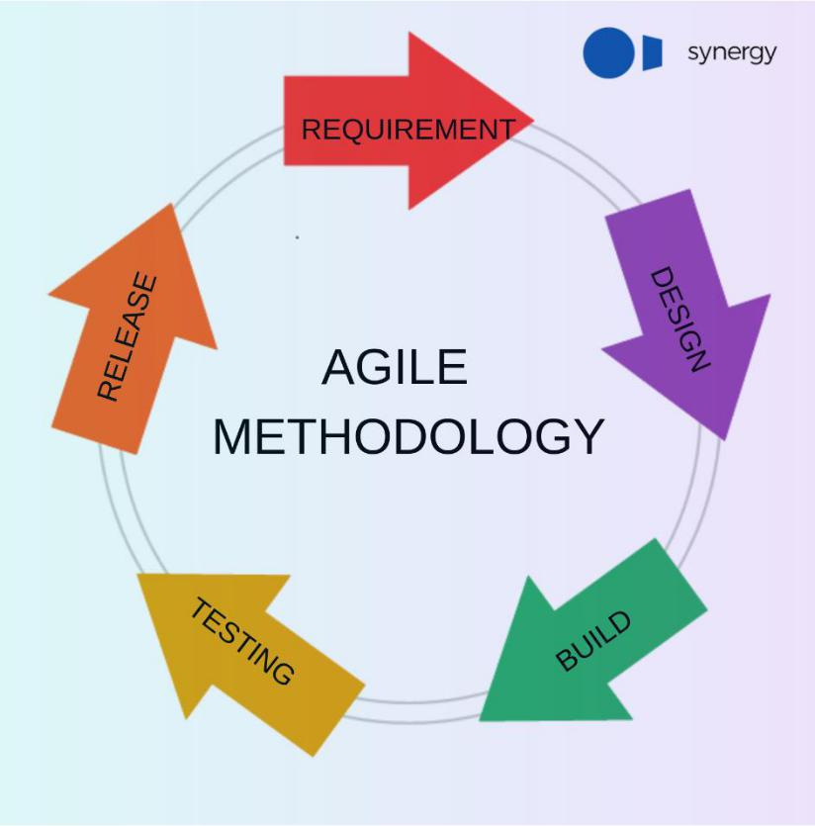

2.2 Service Identification and Scoping

This section will provide details for all business requirements, together with steps provided by the system to accomplish requirement.
7

1. W365 should allow Customers to Register an account
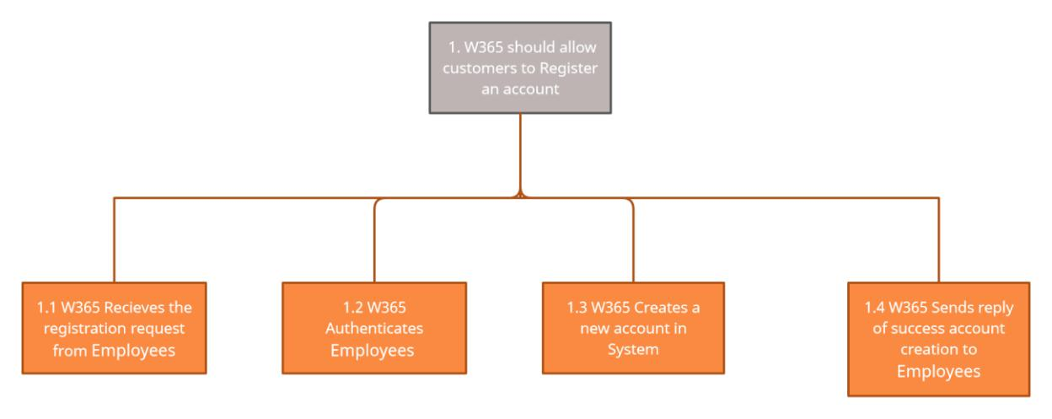

2. W365 should allow Employees to Login to their accounts.
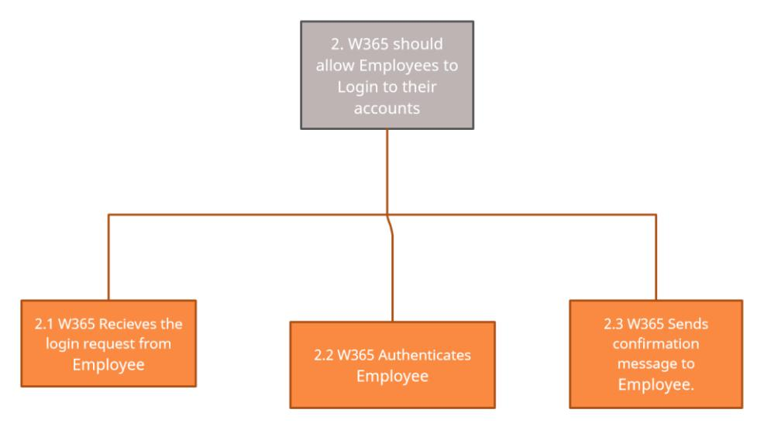

- W365 should allow you to manage paid and unpaid time off without any manual calculations or spreadsheets

8
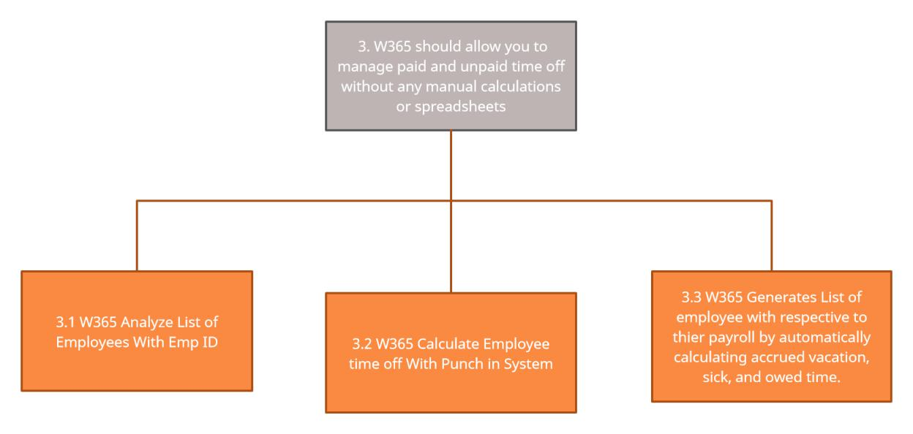

4. W365 should allow you to send push notifications to Employees.
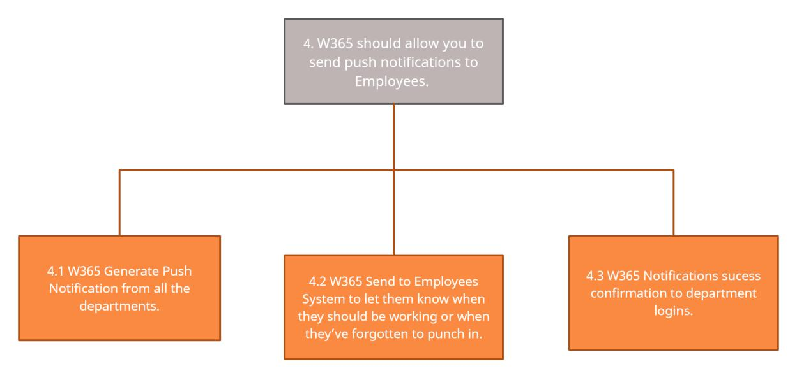

5. W365 should allow you to Add, Update & Delete Employee.

9
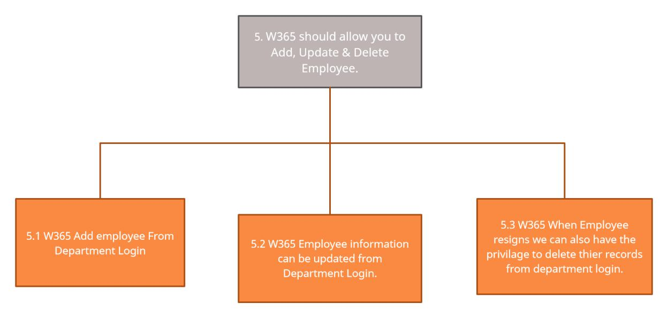

6. W365 should allow Create Notifications for Employees.
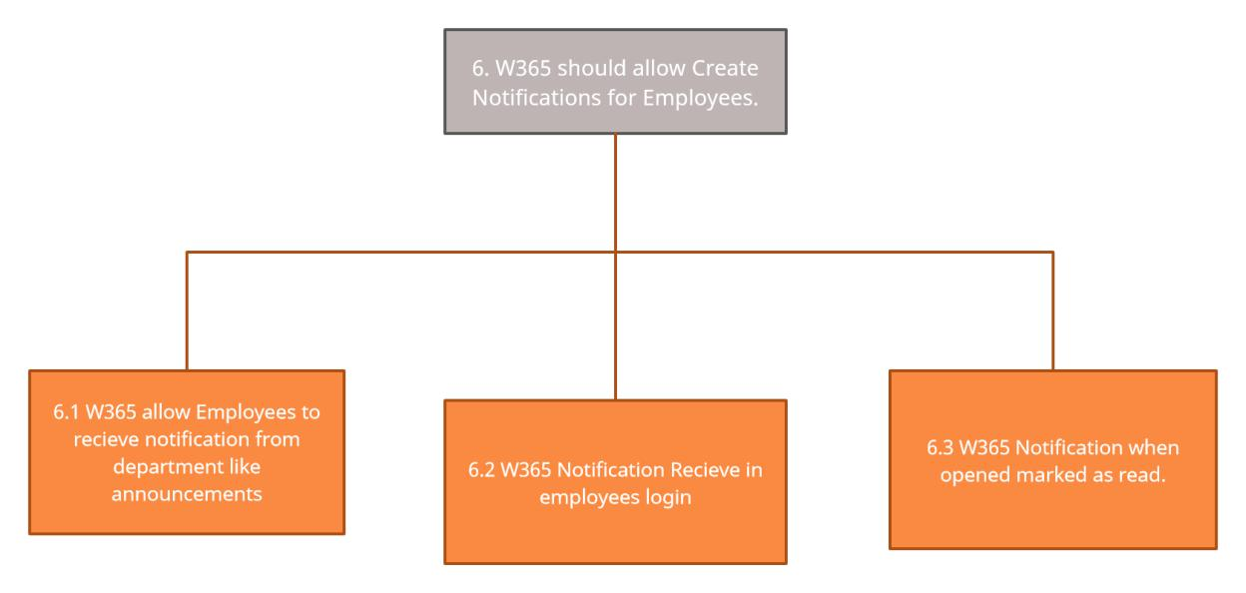
10

7. W365 should allow you to track Employee Shift records.
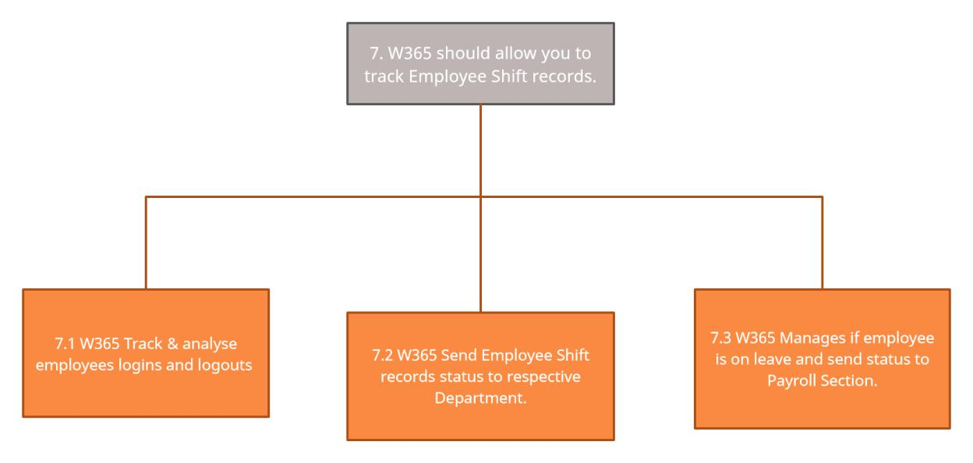

- W365 should allow you to Generate Salary Report of all the employees By Selecting Department.
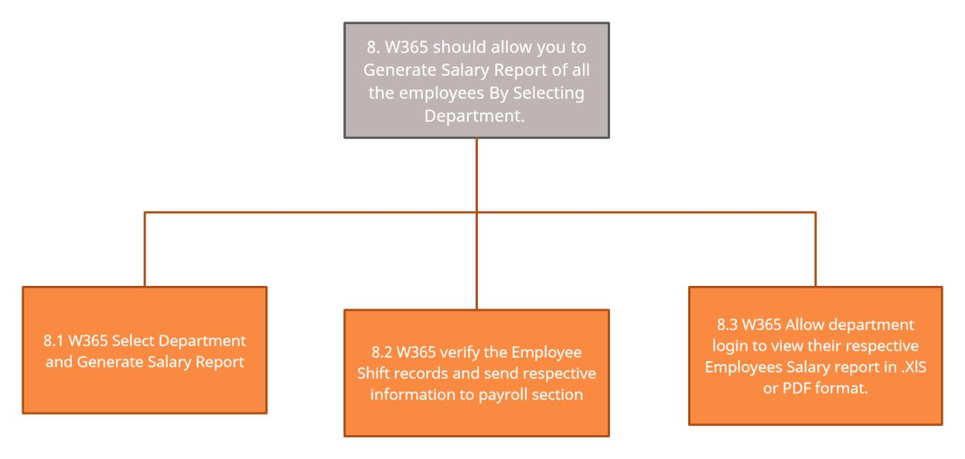
11

2.3 System Processes

This chapter shows basic flow of all business processes.

1. W365 should allow customers to Register an account
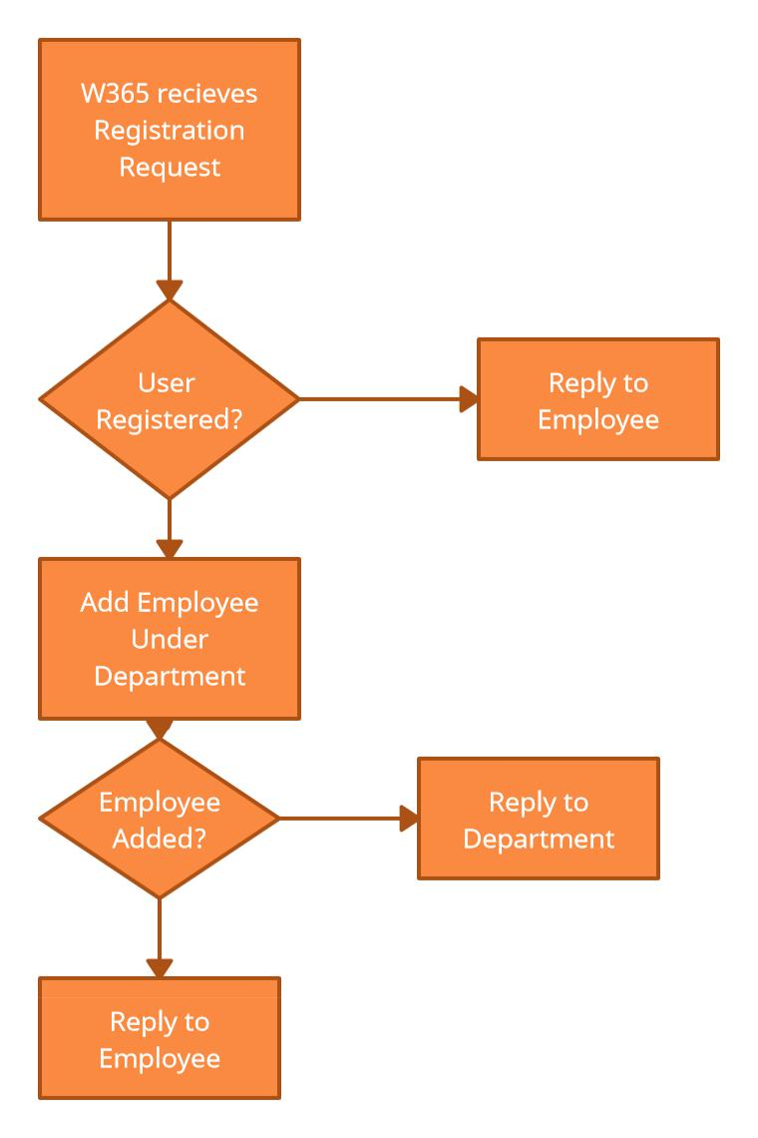
12

2. W365 should allow Employees to Login to their accounts.
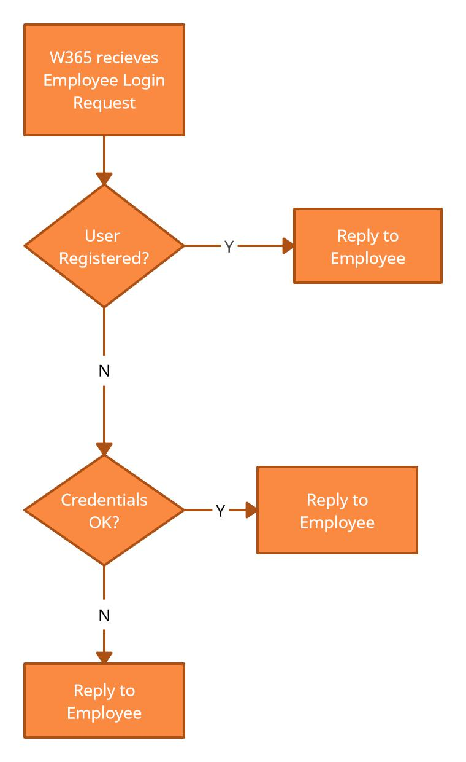
13

- W365 should allow you to manage paid and unpaid time off without any manual calculations or spreadsheets.
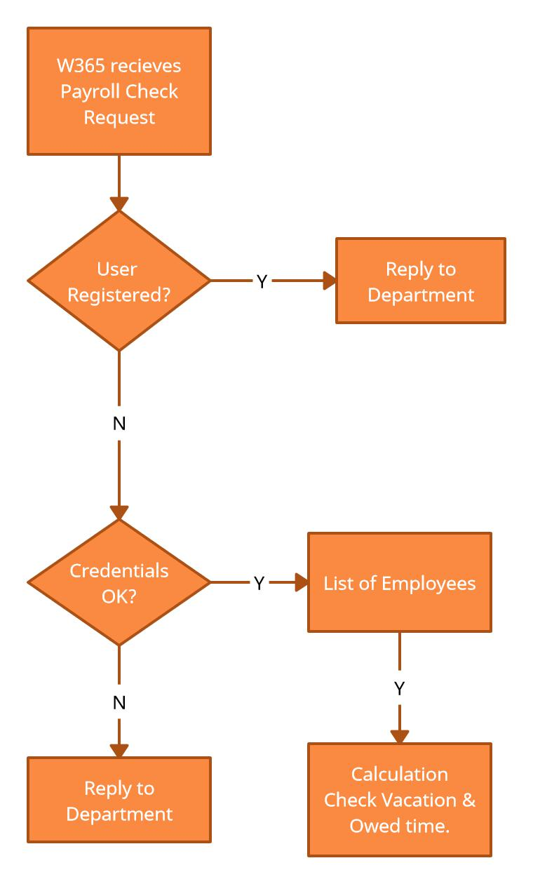
14

4. W365 should allow you to send push notifications to Employees.
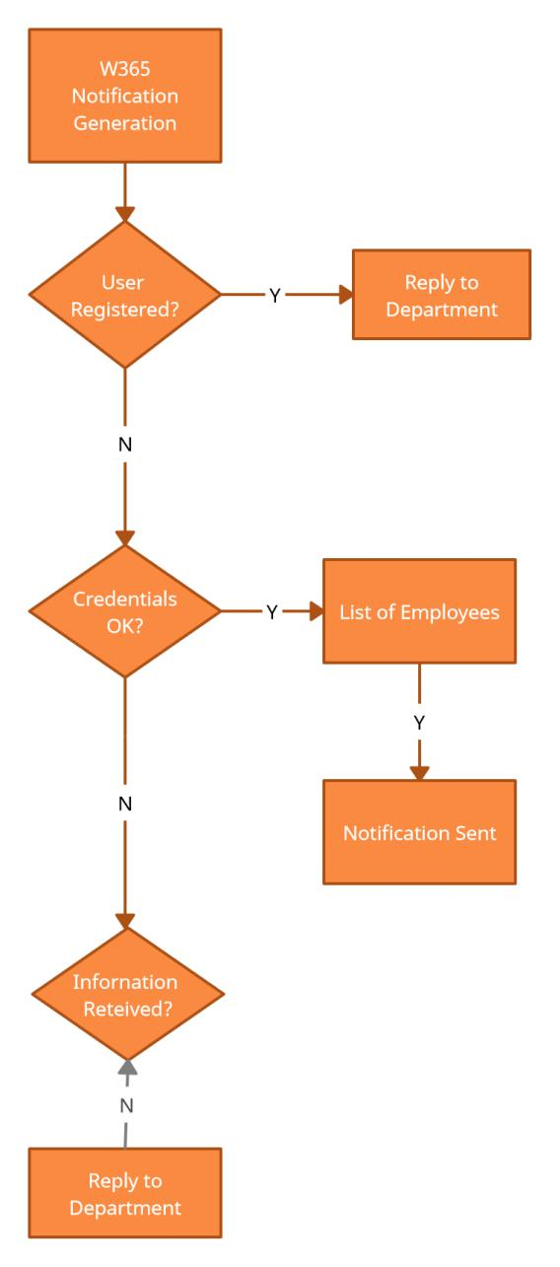
15

5. W365 should allow you to Add, Update & Delete Employee.
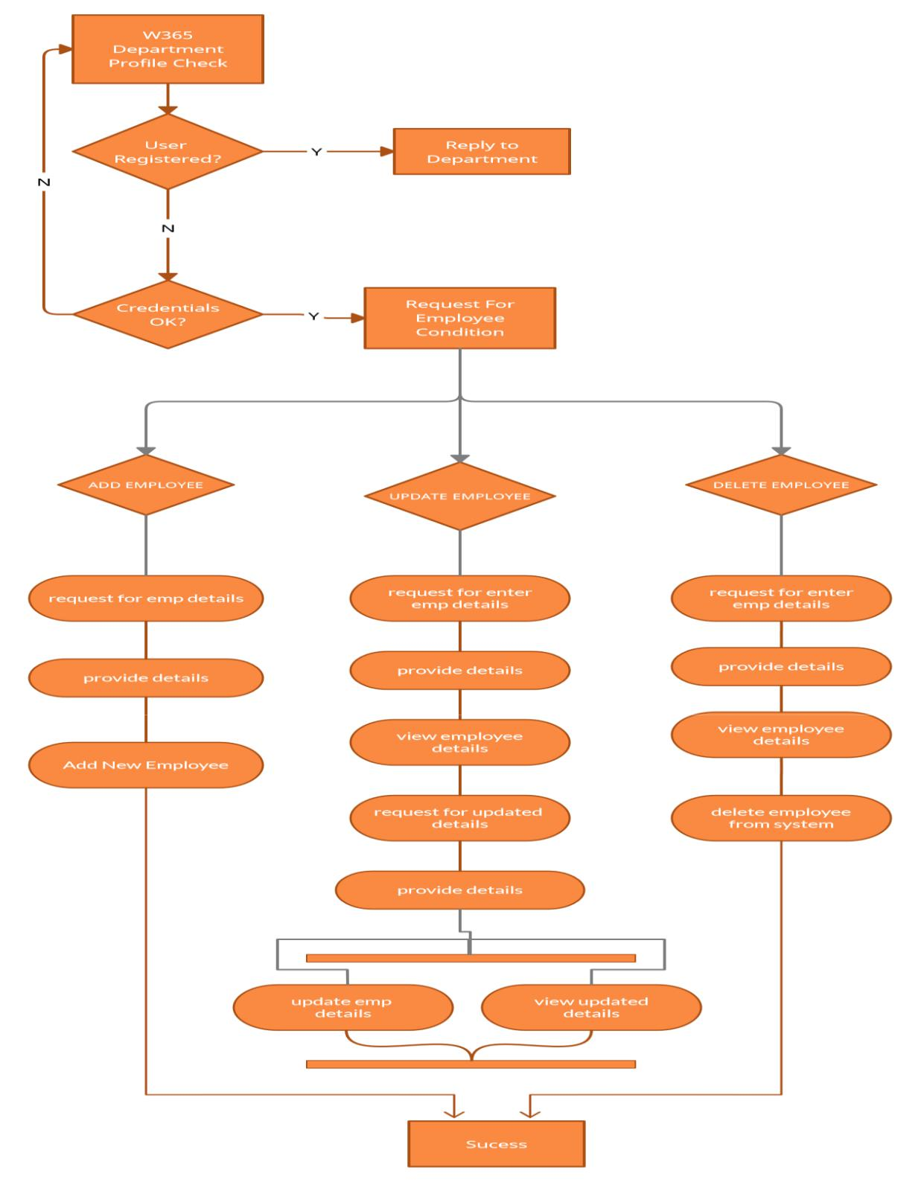
16

6. W365 should allow Create Notifications for Employees.
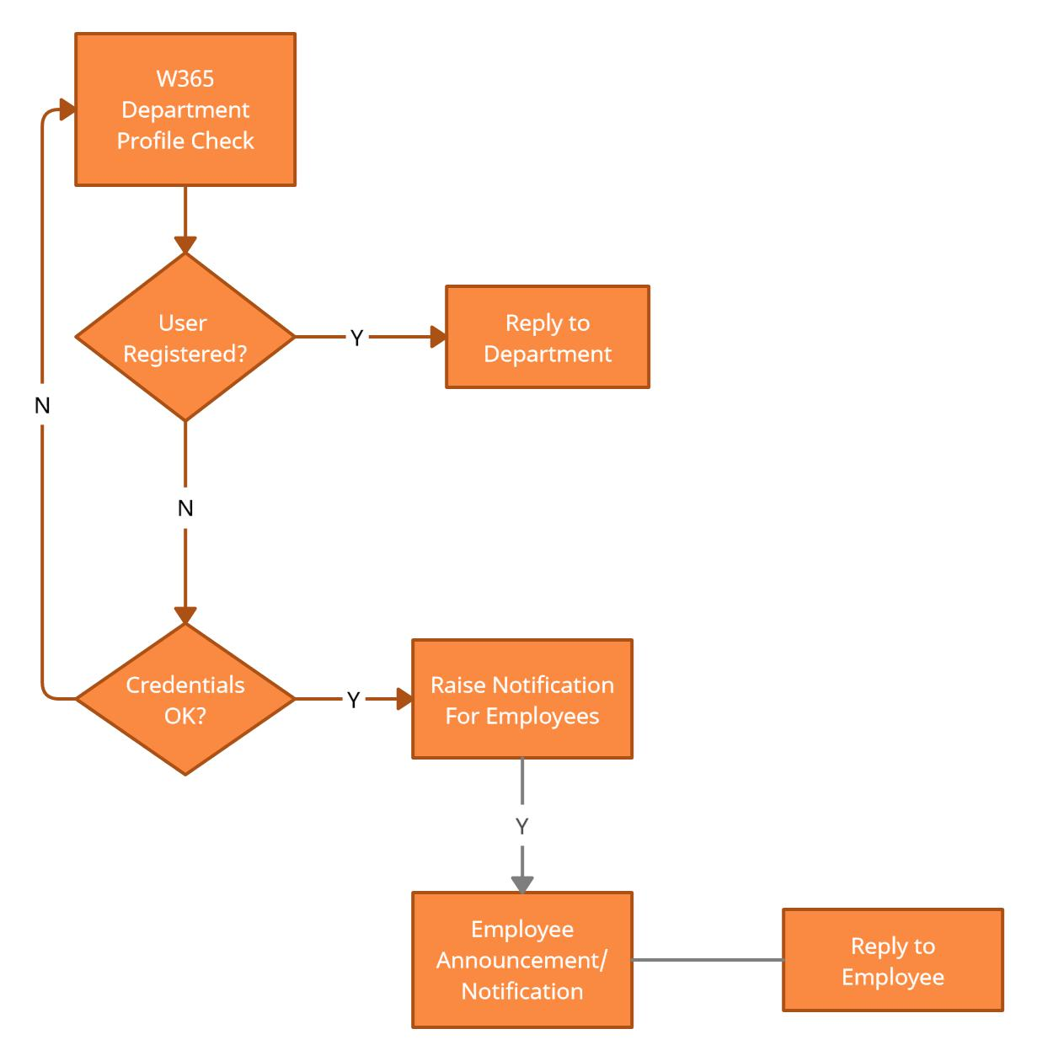
17

7. W365 should allow you to track Employee Shift records.
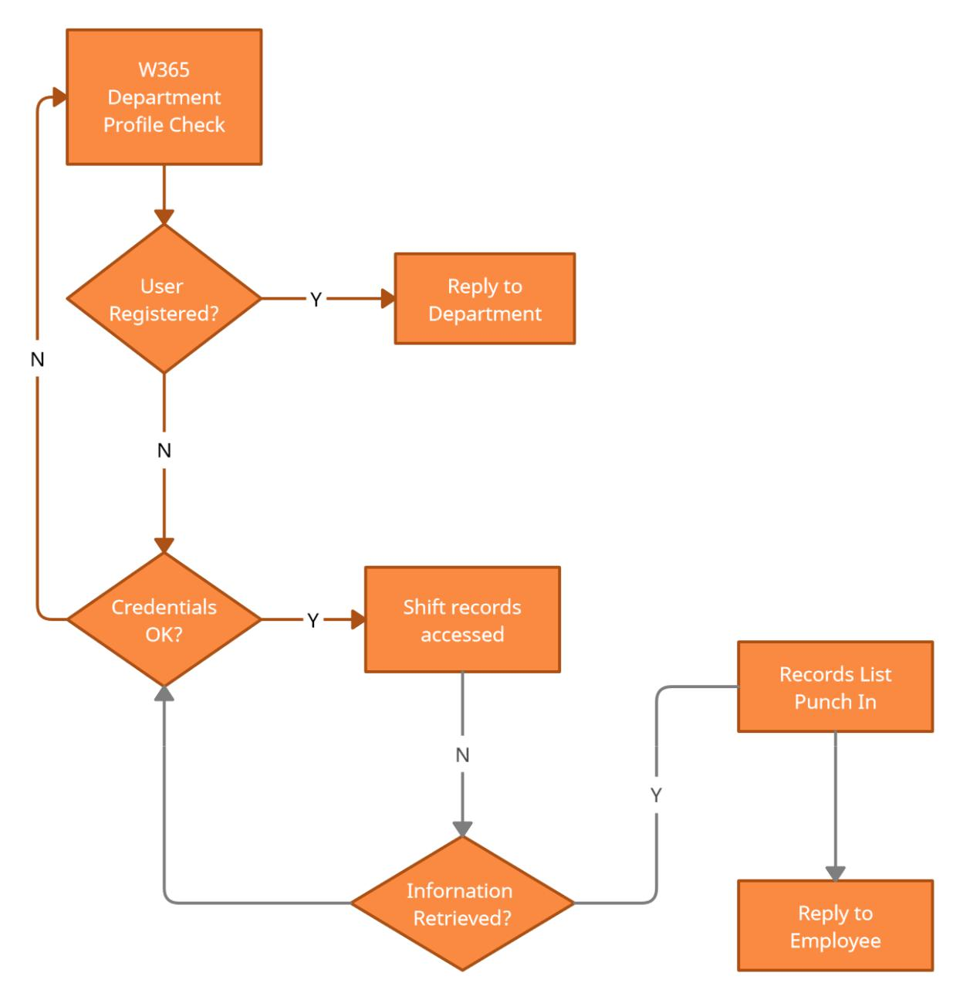
18

- W365 should allow you to Generate Salary Report of all the employees By Selecting Department.
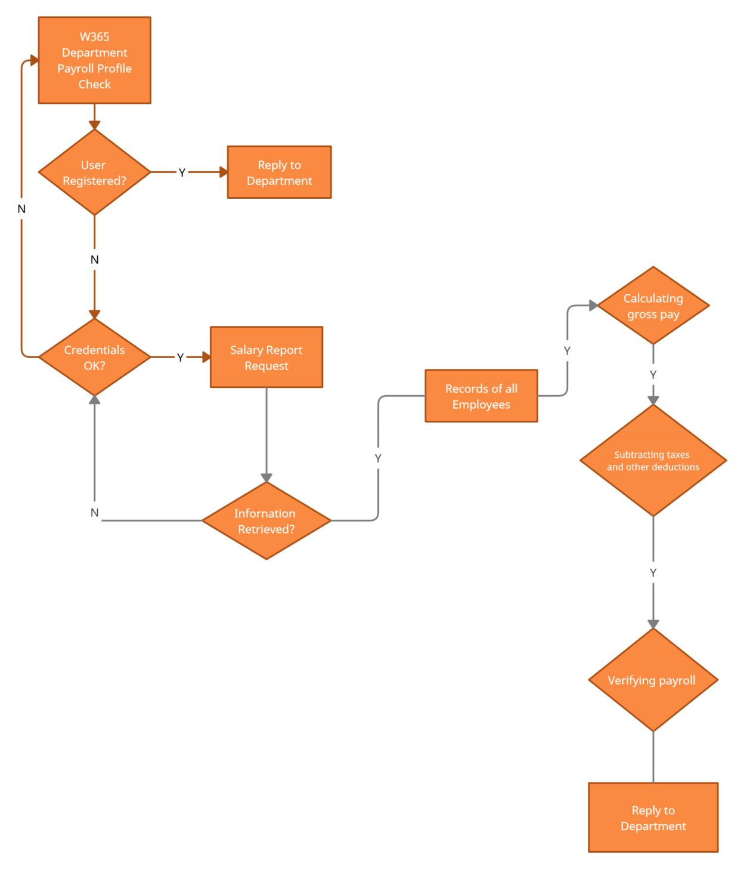
19

3. Service Identification

Table below shows all services needed to accomplish all business requirements.

Name


Employee Management Registration Service Notification Service

Shift Record Service Salary Info Service

Profile Changing Service


BPEL Main Service

Abbreviation |  | Description |  |  |  | Type
EMR |  | Manages Employee |  |  |  | SOAP
 |  | Registration & Login
NS |  | Process Notification for |  |  |  | SOAP
 |  | Punch in &
 |  | Announcements also
SRS |  | Obtain info about |  |  |  | REST
 |  | Employee Workdays
SIS |  | Obtain info about |  |  |  | REST
 |  | Employee Salary
PCS |  | Manages Employee |  |  |  | REST
 |  | profile for Adding,
 |  | Updating & Deleting
 |  | Information
BMS |  | A service to manage and
 |  | coordinate with other
 |  | services

 | Has data |  | Third
 | persistence |  | party
 | No |  | No
 | No |  | No
 | Yes |  | No
 | Yes |  | No
 | Yes |  | No
 | No |  | No

20

4. System Overview

4.1. Use Case Diagram

Figure below shows high level functionality and connection between services
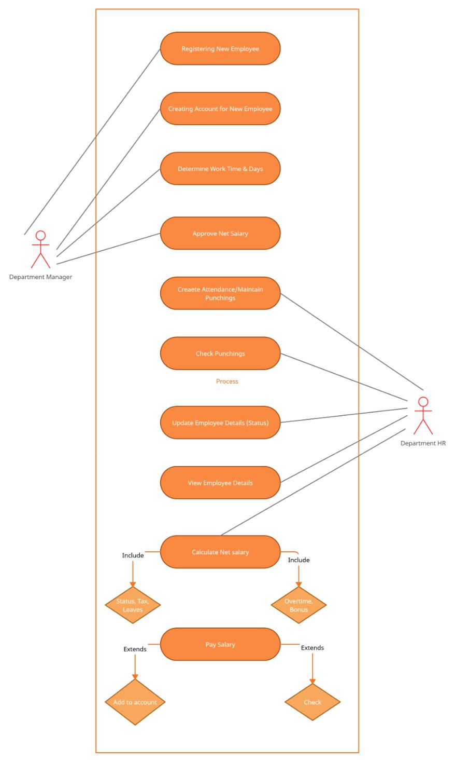
21

4.2 Service Architectural Diagram

The BPEL Main Service implements all system logic and coordinate with other services. Connection between services is shown on Figure below.
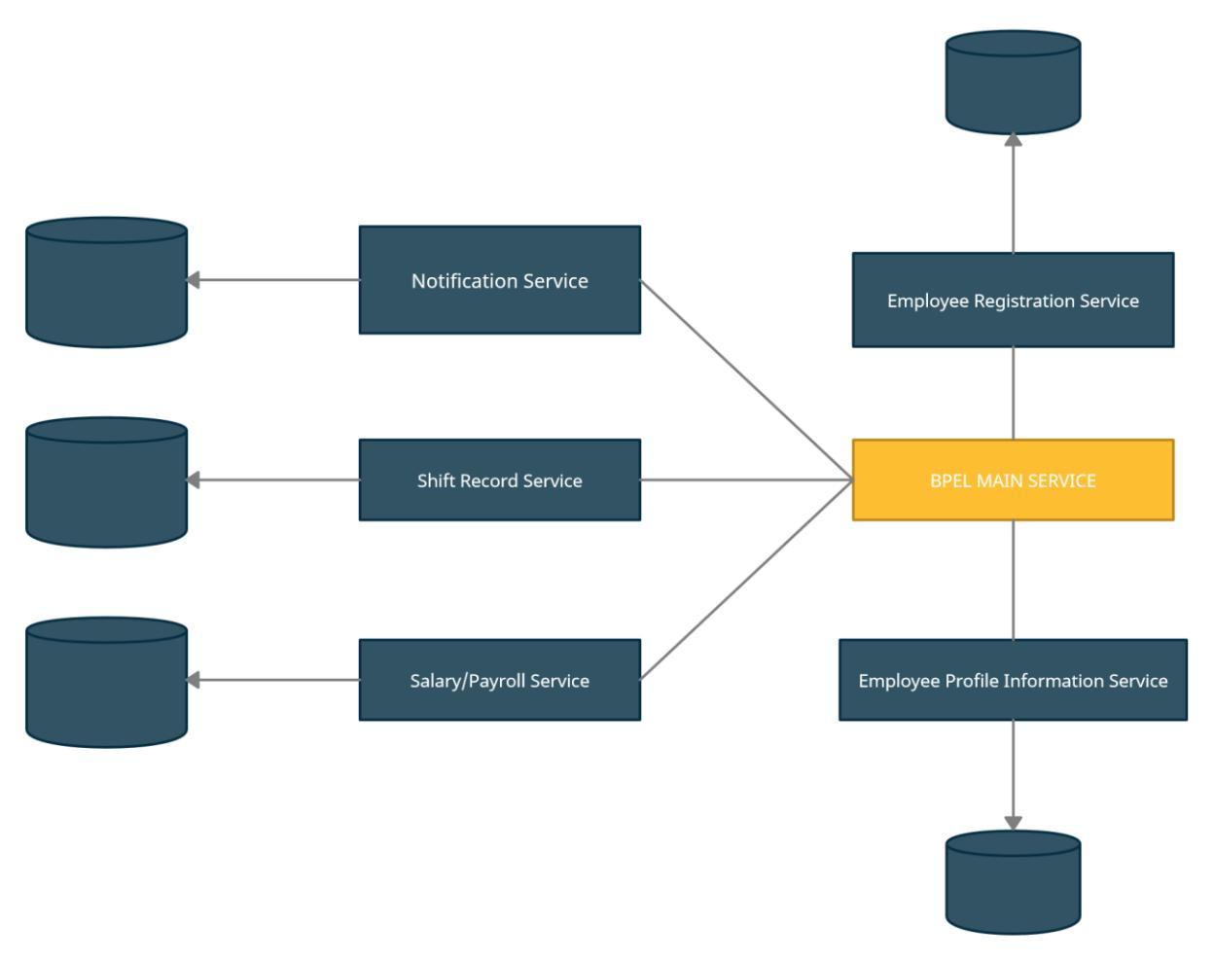
22

4.3 System Overview Diagram

The service W365 Employee management System Get respond with BPEL Main Service, which further linked to services (Notification Service, Salary/Payroll Service, Shift records Service, Profile Information Service & Employee Registration Service)
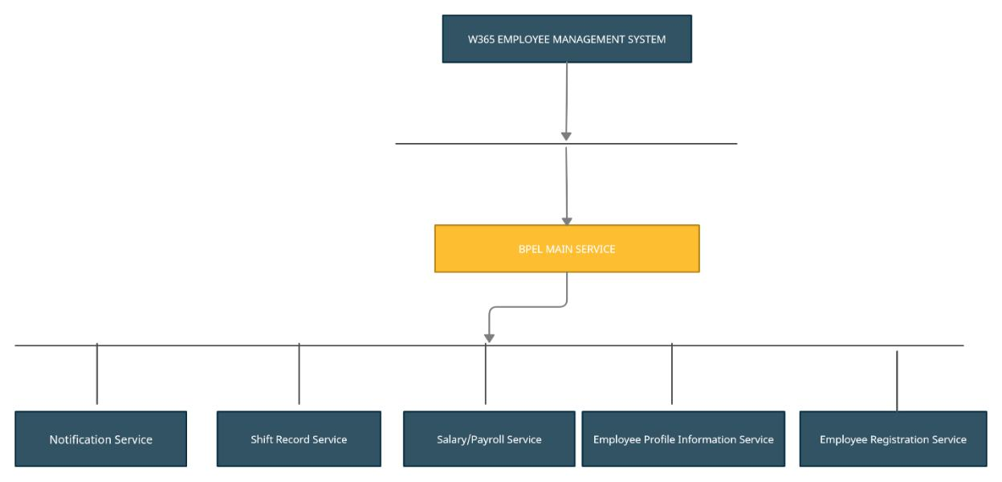
23

5. Discussion

Our system provides the best & effective service which are key points of any Business organization to be run successfully so they can find it very useful. We designed our system in a way that it can cover all the objectives and business rules. Thus, W365 will become the point of interest for everyone.

As system works under controlled and secured environment which mainly focuses on the main processes. We ensure system updates to (like adding new services & features) can be easily achieved using our own service methods and most importantly avoiding the third-party services to our system. Because those system comes with many issues which cause trouble to the security of our system.

Main disadvantages of such system are his cost. Having own services causes much lesser cost rather than using third party services.

This approach uses Service Oriented Approach (SOA) which has many advantages.

Some of them are:

- Maintenance at lesser cost

- Code quality Improvement

- Works on Any platform

- Scalability

- Reliability

- Freedom to use other services

Some of disadvantages of SOA approach are:

- VPS Or Large Bandwidth Servers

- Departmental Overload
24

6. Conclusion

Work365 Employee Management System (W365) provides service which are useful for small to large scale enterprise. W365 will offer re-use of other services and become provider for those services. A such, SOA is used as most appropriate approach.

W365 provide the stability to store large amount of data into their system. Enterprises can use all the services when they enrolled to the system. Our application offers Registration and login process into the system as we can make different departments and under those departments we can store as many employees according to the requirements.

As such, W365 offers all services needed to the Management system.
25

7. References

2021, M. (2021, August 18). Flowchart Maker and Diagramming Software. Retrieved from Microsoft.com. 2021: https://www.microsoft.com/en-ww/microsoft-365/visio/flowchart-software

Redhat. (2021, August 18). What is service-oriented architecture (SOA)? Retrieved from redhat.com: https://www.redhat.com/en/topics/cloud-native-apps/what-is-service-oriented-architecture

Service-Oriented Architecture. (2021, August 18). Retrieved from https://www.geeksforgeeks.org/service-oriented-architecture/

Bartram, T., 2011. Employee management systems and organizational contexts: a population ecology approach. Management Research Review.

Greenwald, R., Stackowiak, R. and Stern, J., 2013. Oracle essentials: Oracle database 12c. " O'Reilly Media, Inc.".

Spurlock, J., 2013. Bootstrap: responsive web development. " O'Reilly Media, Inc.".

